

MSE 491 – Electrified Transportation Systems – Spring 2026
- Laboratory Report -
Vehicle Dynamics Model for Road-Load Performance Study for a BEV

Abstract
This laboratory experiment investigates the longitudinal acceleration performance of a 2015 Nissan Leaf Battery Electric Vehicle (BEV) using a simplified vehicle dynamics model developed in MATLAB/Simulink. The objective was to simulate the interaction between the electric powertrain's motive force and external road-load forces, including aerodynamic drag, rolling resistance, and gravitational climbing force. The simulation evaluated the vehicle’s acceleration from a standstill to maximum speed under three scenarios: a baseline test on a flat surface, wind condition tests with 15 km/h headwind and tailwind, and gradient tests on 6-degree and 12-degree slopes. The results indicate that road slope is the dominant factor affecting EV acceleration, with the 12-degree incline causing a significant reduction in performance due to the constant gravitational load. Conversely, the impact of the tested wind conditions was found to be marginal during the acceleration phase. The study successfully validates the torque-limited and power-limited operating regions of the electric motor and highlights the sensitivity of single-speed EVs to road grade.

Introduction
The dynamic performance of Battery Electric Vehicles (BEVs) is fundamentally governed by the interaction between the electric motor's torque-speed characteristics and the external resistive forces acting on the vehicle. Unlike internal combustion engine vehicles, which typically rely on multi-speed transmissions to optimize torque delivery across different speeds, many modern BEVs utilize a single-speed reduction gear. Consequently, the vehicle's acceleration capabilities are directly dependent on the motor's ability to overcome road-load forces—specifically aerodynamic drag, rolling resistance, and gravitational climbing force—across its entire operating range.
The primary objective of this laboratory experiment is to develop and validate a longitudinal vehicle dynamics model for a 2015 Nissan Leaf using MATLAB/Simulink. By implementing the fundamental equations of motion and the specific parameters of the vehicle, the model simulates the motive force provided by the electric powertrain against opposing environmental loads. This study aims to quantify the vehicle's acceleration performance from a standstill to its maximum speed and analyze its sensitivity to varying operating conditions, including headwind, tailwind, and road gradients.

Theoretical Analysis
Road-Load Torque Block
This block models the resistive torque acting on the vehicle due to road-load effects, including rolling resistance, spinning/rotational losses, and aerodynamic drag. The road-load force is expressed as:
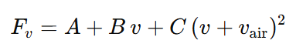
The corresponding torque is obtained by multiplying the road-load force by the effective wheel radius:
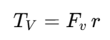

Climbing Torque Block
This block models the resistive torque acting on the vehicle due to road slope. The climbing force is generated by the component of the vehicle’s weight acting parallel to the road surface and is given by:
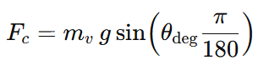
The corresponding climbing torque at the wheel is obtained by multiplying the climbing force by the effective wheel radius:
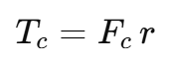
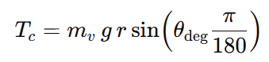

Resistive Torque Block
This block models the torque available from the drivetrain based on the BEV’s speed–torque and power characteristics:
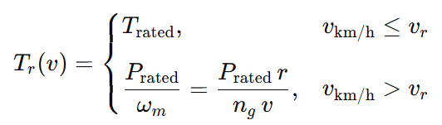
At low vehicle speeds, the motor operates in a constant-torque region and delivers the rated torque. Once the vehicle speed exceeds the rated speed v_r, the motor transitions to a constant-power region, causing the available torque to decrease inversely with speed.

Vehicle/Wheel Block
This block models the dynamics of the vehicle by combining the tractive torque from the drivetrain with the resistive torques acting at the wheels. The net torque applied at the wheel is given by
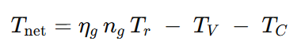
The net force at the tire–road interface is obtained by converting torque to force using the effective wheel radius:
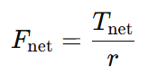
To account for the rotational inertia of drivetrain components, an equivalent (fictitious) mass is introduced:
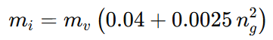

The total equivalent mass used is then:
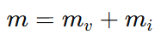
Applying Newton’s second law, the vehicle acceleration is computed as:
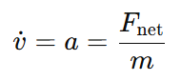
Finally, the vehicle speed is obtained by integrating the acceleration over time:
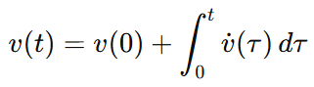

Calculations, Simulation results and Discussions/explanations

Part A
A.1 Referring to Figure 1 and the dynamic equations in Chapter 2 of the textbook (Electric Powertrain), build a dynamic model of the vehicle with the parameters given in Table I in Simulink. Consider the wind speed vair, the slope angle of the road θ, as variables. For taking the moment of inertia of the drive-axle into account, use the following to calculate its equivalent fictitious mass:
m_i = m_c(0.04 + 0.0025n_g^2)
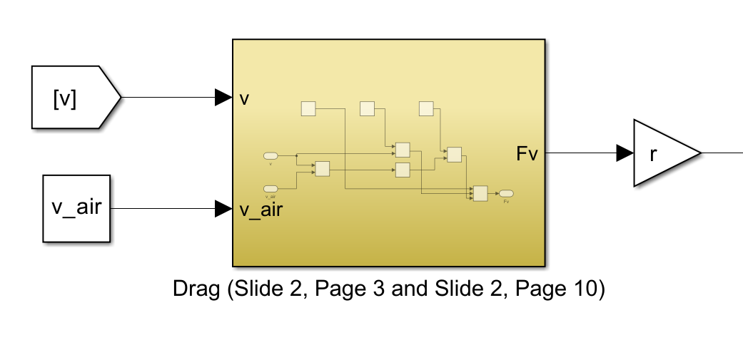
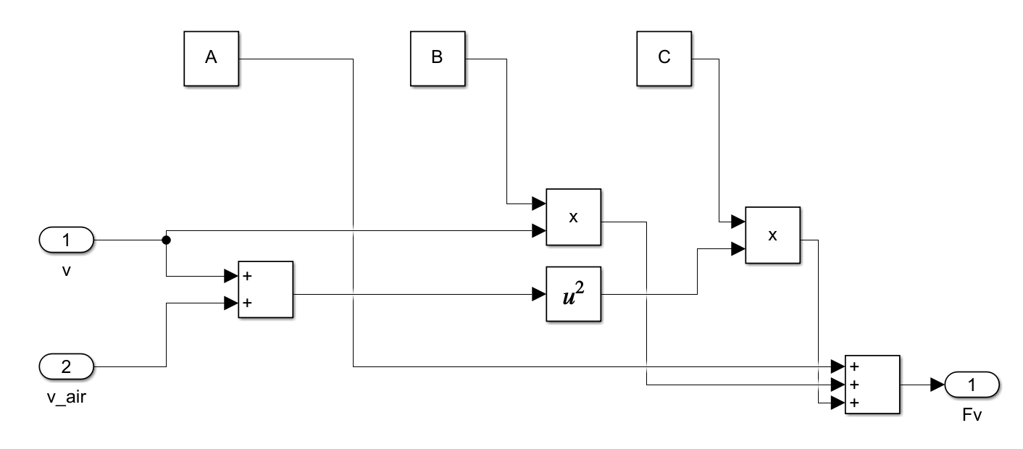
Figure 1: Block diagram model of Fv (Road load force)
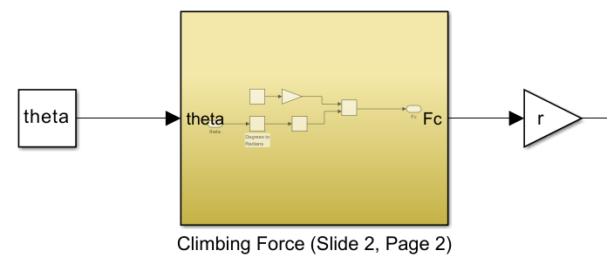
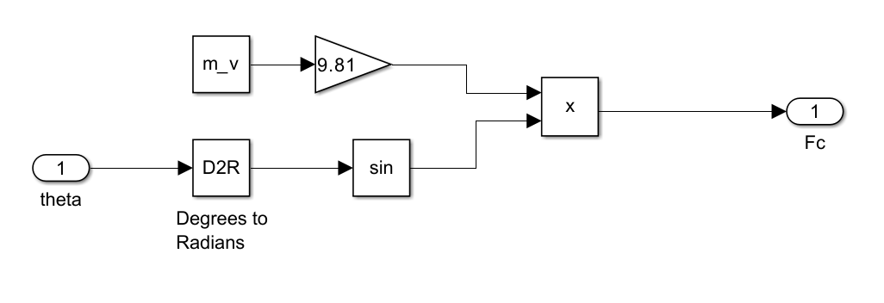
Figure 2: Block diagram model of Fv (Road load force)
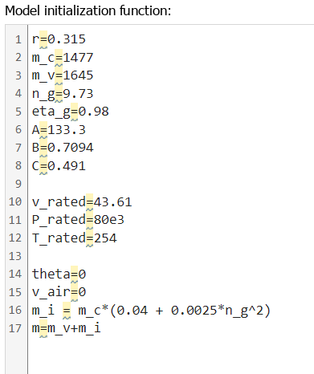
Figure 3: Model initialization functions
A.2 Implement the speed-torque profile according to the power and torque characteristics of the vehicle (similar to Figure 2.7 in the textbook). Incorporate the profile in the simulation model.
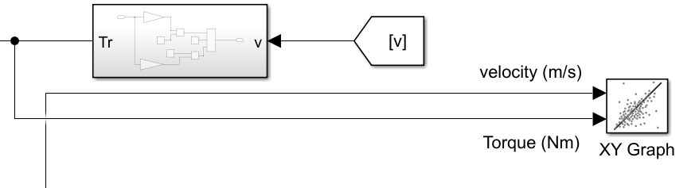
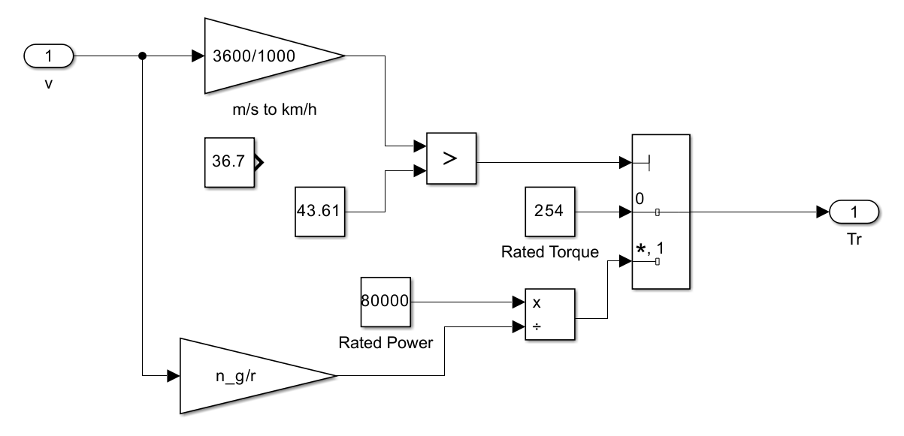
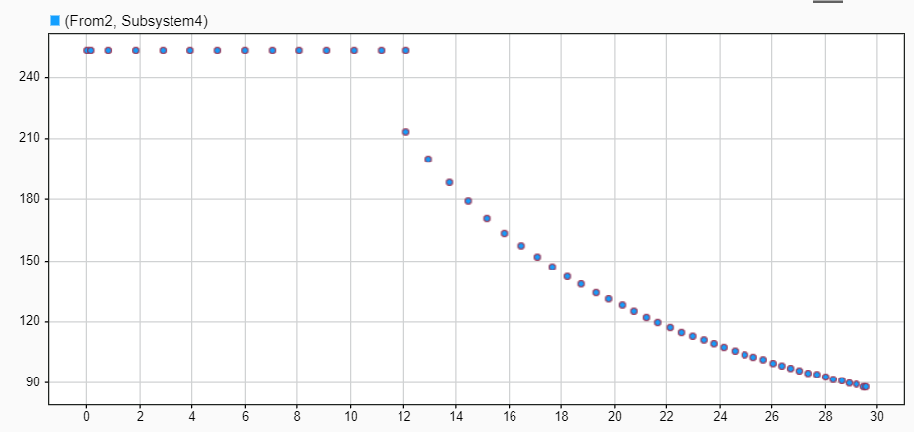
Figure 4: Speed-torque profile (with 43.61km/hr as constant in Tr block)
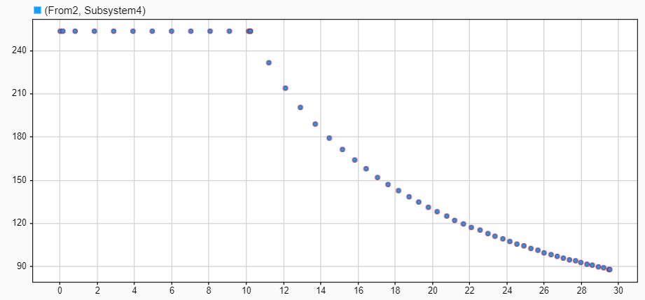
Figure 5: Speed-torque profile (with 36.7km/hr as constant in Tr block)

A.3 Show all the equations used and its corresponding step-by-step-derivation.
The vehicle's acceleration is governed by Newton's Second Law of Motion for a rotating system projected onto the longitudinal axis.
1. Newton's Second Law
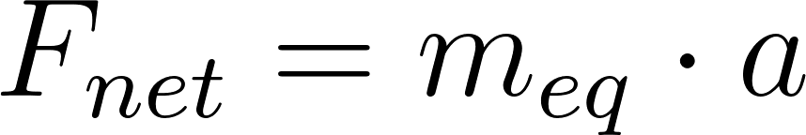
Where:
- F_net is the total force acting on the vehicle.
- m_eq is the equivalent inertial mass.
- a is the acceleration (dv/dt).
2. Equivalent Mass (m_eq)
To account for the rotational inertia of the drivetrain components (motor, gears, axles) without modeling them individually, they are converted into an equivalent translational mass (m_i) and added to the static vehicle mass (m_v).
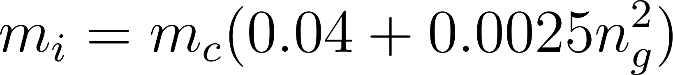

3. Motive Force (F_t)
The electric motor generates a torque (T_motor) which is multiplied by the gear ratio (n_g) and transmission efficiency (eta_g), then converted to a linear force at the wheel radius (r).
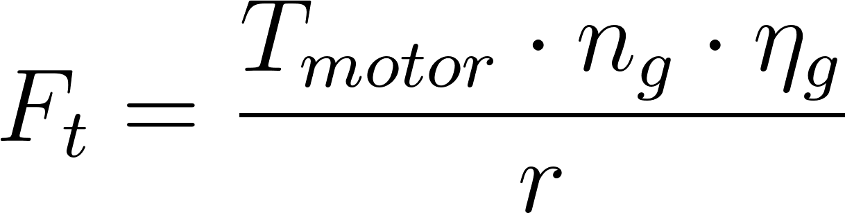
Note: The motor torque T_motor is determined by the motor characteristic curve (Constant Torque region vs. Constant Power region).
4. Resistive Forces
The total resistive force is the sum of road load (rolling resistance + aerodynamic drag) and gravitational climbing force.
- Road Load:
Based on the Simulink model structure (Figure 2), the road load equation incorporates the EPA coast-down coefficients (A, B, C) and accounts for relative air speed.
  - A: Constant rolling resistance and mechanical friction.
  - B: Viscous rolling resistance (linear with speed).
  - C: Aerodynamic drag coefficient factor (proportional to relative air speed squared).

- Climbing Force:
The gravitational force component opposing motion on a slope theta.
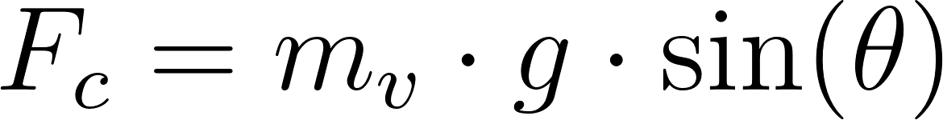
5. Final Equation of Motion
Combining the motive and resistive forces:
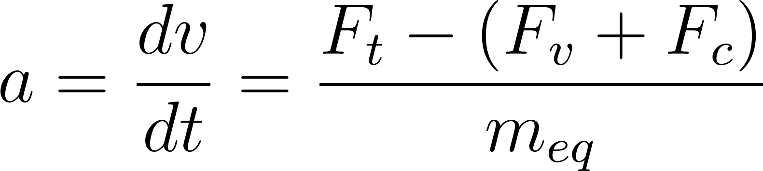
Substituting the detailed terms:
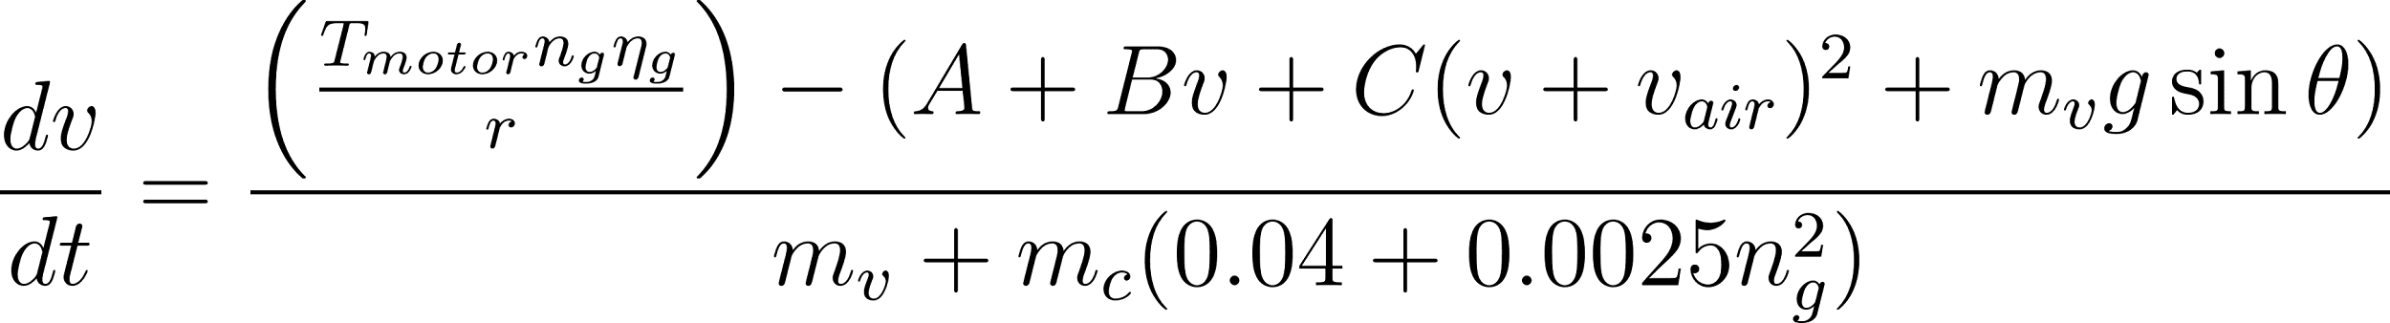

Part B
B.1 Assuming wind speed is zero and the vehicle in running on a flat surface (θ = 0), run simulation with the model for quickest possible acceleration from zero speed to maximum vehicle speed. Use maximum possible torque/power provided by the vehicle for the test.
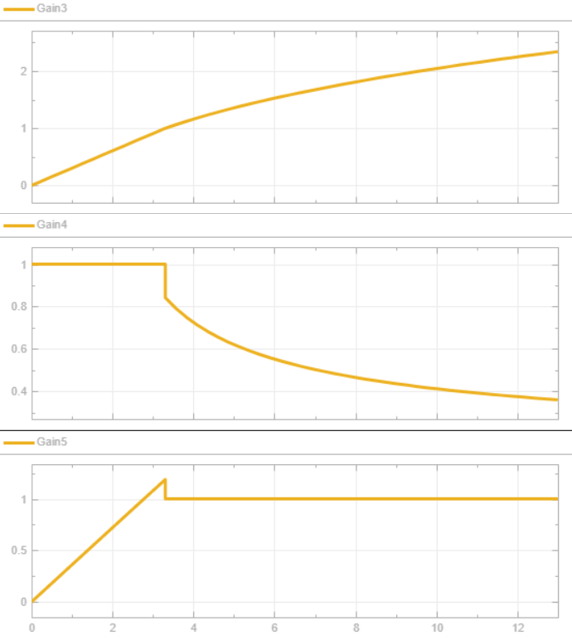
Figure 6: Model output (θ=0, V_air=0m/s, with 43.61km/h)
B.2 Change the wind speed to 15 km/h (headwind and tailwind, respectively) while keeping slope angle as zero, run simulations with the model for the same acceleration test as in B.1.
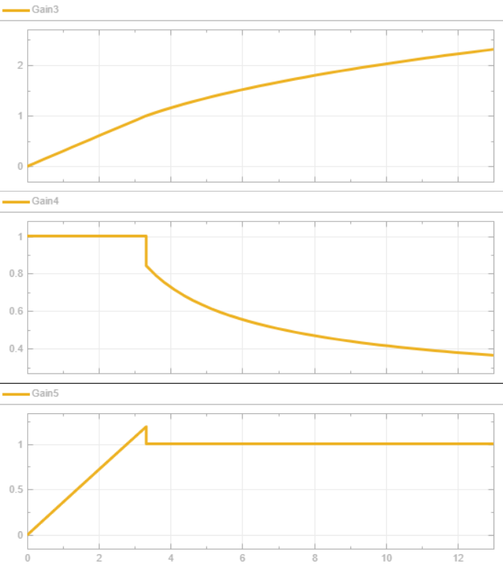
Figure 7: Model output (θ= 0, V_air= 4.167m/s = 15km/h, with 43.61km/h)

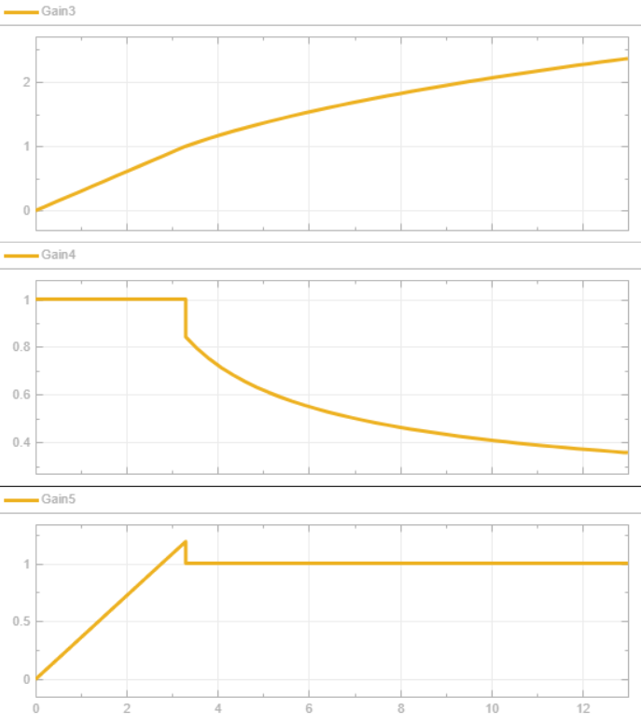
Figure 8: Model output (θ= 0, V_air= -4.167m/s = -15km/h, with 43.61km/h)

B.3 Change the wind speed back to zero; set the slope angle to 6 ̊ and 12 ̊, respectively (uphill), run simulation with the model for the same acceleration test as in B.1.
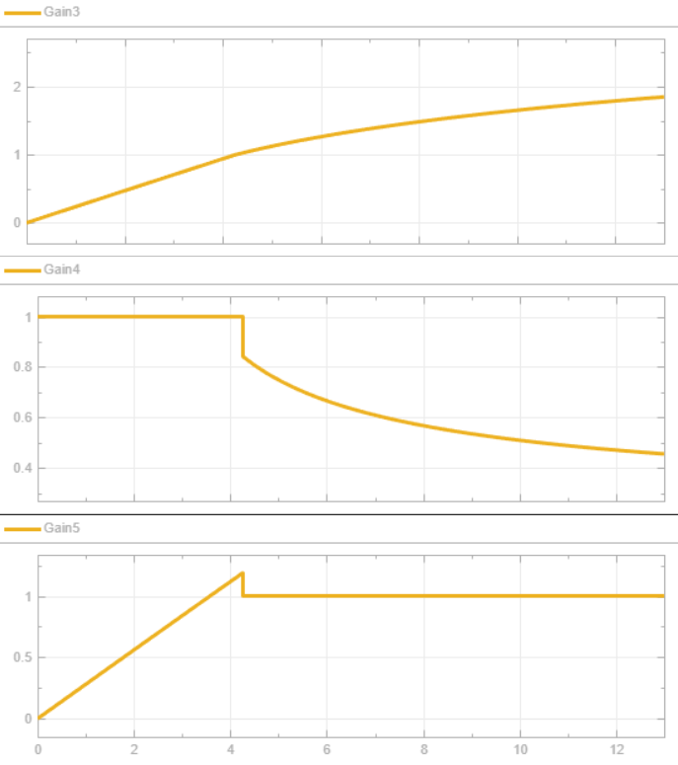
Figure 9: Model output (θ= 6 ̊ , V_air= 0, with 43.61km/h)

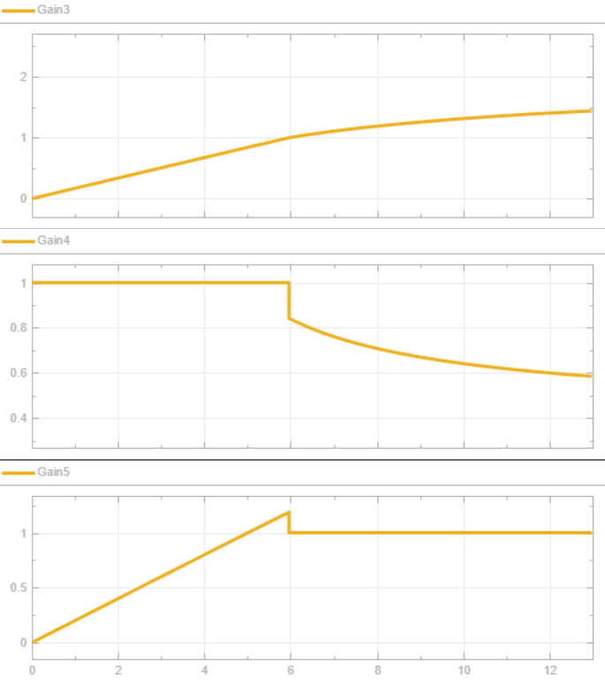
Figure 10: Model output (θ= 12 ̊ , V_air= 0, with 43.61km/h)

B.4 Plot the speed, torque, and power curves versus time (from zero speed to maximum speed of the vehicle) for each of the above tasks. Analyze your simulation results and draw conclusions through comparisons.
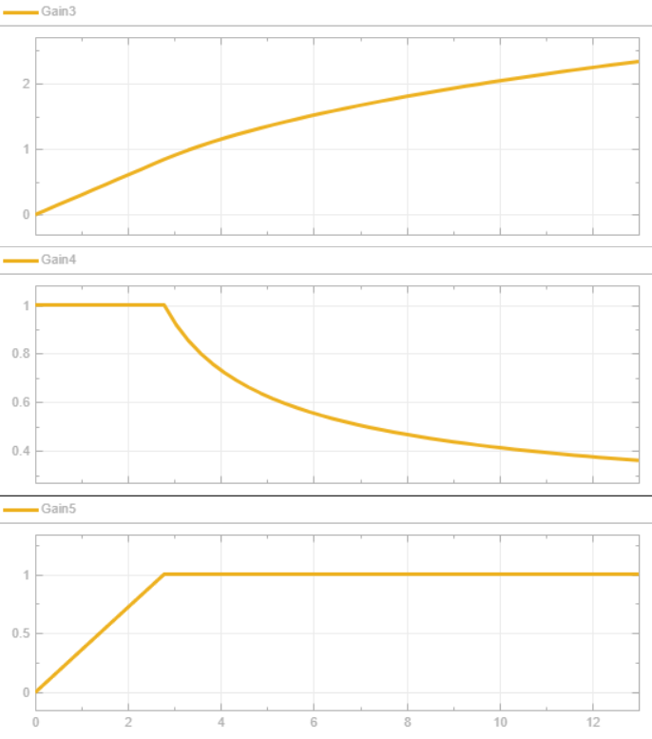
Figure 11: Model output (θ=0, V_air=0m/s, with 36.7km/h)

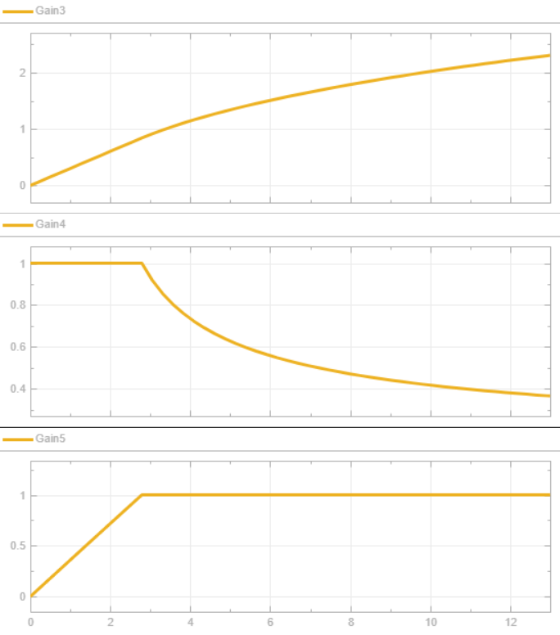
Figure 12: Model output (θ= 0, V_air= 4.167m/s = 15km/h, with 36.7km/h)
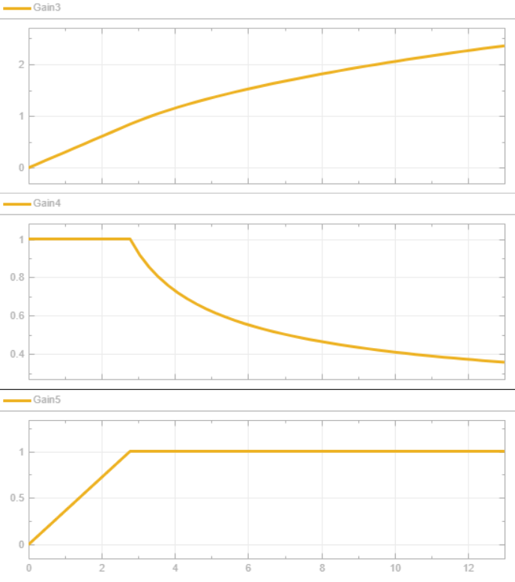
Figure 13: Model output (θ= 0, V_air= -4.167m/s = -15km/h, with 36.7km/h)
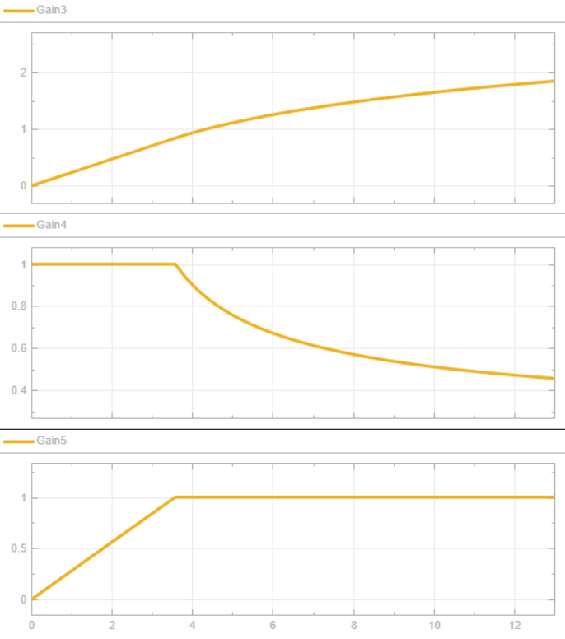
Figure 14: Model output (θ= 6 ̊ , V_air= 0, with 36.7km/h)
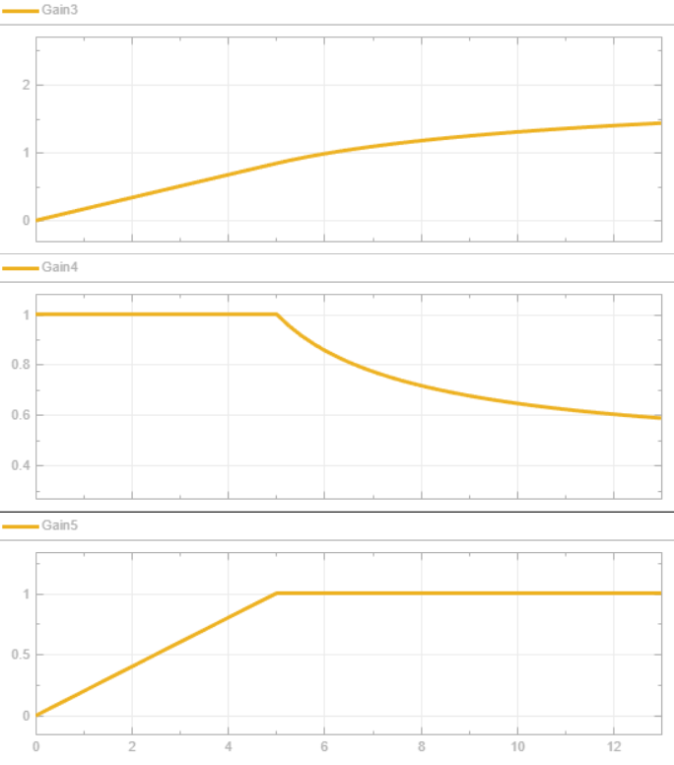
Figure 15: Model output (θ= 12 ̊ , V_air= 0, with 36.7km/h)

The simulation results plotted in Sections B.1 through B.3 illustrate the vehicle's performance limits under varying loads. The plots display normalized values for Speed (Top), Torque (Middle), and Power (Bottom) over a 13-second acceleration run.

Transition Speed Between Constant Torque and Constant Power Regions
With a rated motor speed of 43.61 km/h, an overshoot above 1 was observed in the normalized power diagram. This indicated an inconsistency in the transition between the constant-torque and constant-power regions. As a result, the rated speed was re-evaluated, and a value of 36.7 km/h was determined to be more appropriate to ensure that the torque and power characteristics remain physically and logically consistent.
The traction torque follows a piecewise characteristic: constant torque at low speed and constant power beyond a transition speed. This transition occurs when the motor reaches its rated power while operating at the rated torque.
The rated motor angular speed is obtained from the rated power and rated torque:
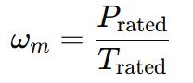
Substituting the given values,
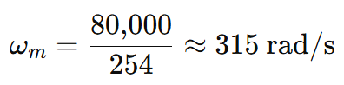
The vehicle speed is related to the motor speed through the gear ratio n_g​ and wheel radius r:
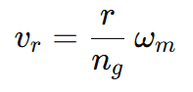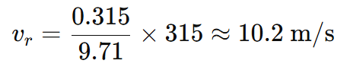
Converting to km/h:
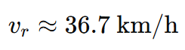
Therefore, the traction torque model is expressed as:
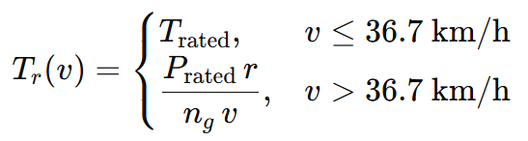

1. Baseline Performance (Flat, No Wind)
The vehicle exhibits the characteristic electric motor profile:
- Constant Torque Region: From t=0 to t=3 seconds (approx.), the motor delivers maximum rated torque (1.0 pu). Acceleration is highest here.
- Constant Power Region: Once the vehicle reaches rated speed (approx. 43.6 km/h), torque decreases hyperbolically (1/v) to maintain constant power (1.0 pu). Acceleration gradually decreases as available torque drops.

2. Effect of Wind (Aerodynamic Drag)
- Headwind (15 km/h): The impact on acceleration in the first 12 seconds is marginal. Since aerodynamic drag scales with the square of relative speed (F_drag is proportional to (v + v_air)^2), the resistive force is relatively low during the initial launch. The divergence from the baseline would become more pronounced at highway speeds.
- Tailwind (15 km/h): Similarly, the assistance provided by the tailwind yields a negligible improvement in this short acceleration window.
3. Effect of Road Slope (Gravitational Load)
- Gradient Impact: Road slope has a dominant impact on performance. Unlike drag, the gravitational component (F_c = mg * sin(theta)) is a constant force acting against the vehicle from a standstill.
- 6-Degree Slope: The acceleration rate is noticeably reduced. The vehicle takes longer to reach the rated speed, extending the Constant Torque region slightly.
- 12-Degree Slope: Performance degrades significantly. The net motive force (F_net = F_t - F_resistive) is drastically reduced. The speed curve flattens considerably, indicating the vehicle is struggling to build momentum against gravity.

C.1 Based on your simulation results in Part B, discuss how wind conditions and road slope would affect the real-world driving performance of an electric vehicle (EV) compared to a conventional internal combustion engine (ICE) vehicle during acceleration. In your discussion, relate the observed changes in speed, torque, and power curves to practical driving experiences such as highway headwinds, uphill driving, gear shifting in ICE vehicles, and the torque-limited versus power-limited operation of EVs. Explain which vehicle type would be more sensitive to aerodynamic drag and road grade, and why

Based on the simulation, EVs and Internal Combustion Engine (ICE) vehicles react differently to environmental loads due to their distinct powertrain characteristics.
1. Response to Road Slope (Uphill Driving) The EV demonstrates superior driveability on slopes due to its ability to deliver maximum torque at zero RPM. In the simulation, the motor instantly outputs peak torque to counteract the 6° and 12° gradients. In contrast, an ICE vehicle generates little torque at low RPMs and relies on a transmission to multiply torque. On a steep hill, an ICE driver would experience a delay while the transmission downshifts to access higher engine speeds, whereas the EV provides immediate, seamless power.
2. Sensitivity to Aerodynamic Drag (Highway Headwinds) While both vehicle types face the same physical drag forces, the EV is operationally more sensitive to headwinds in terms of efficiency and range. Because the EV powertrain is highly efficient (approx. 90%+), the additional load from a headwind represents a larger percentage increase in total energy consumption compared to an ICE, which wastes significant energy as heat regardless of load. However, in terms of acceleration performance, the EV's lack of gear shifts allows for smoother power delivery against drag compared to an ICE, which acts as a "power-limited" source requiring gear management to maintain acceleration.
3. Conclusion on Sensitivity The EV is more sensitive to road grade regarding pure acceleration capability because it typically relies on a single-speed transmission; it cannot "shift down" to gain mechanical advantage at the wheels beyond its fixed gear ratio. Conversely, an ICE vehicle can mitigate slope effects by selecting lower gears but suffers from torque interruption during shifts.

Conclusions
In this laboratory experiment, a longitudinal vehicle dynamics model for a 2015 Nissan Leaf was successfully developed and simulated using MATLAB/Simulink. The objective was to analyze the vehicle's road-load acceleration performance by modeling the interaction between the electric powertrain's motive force and external resistive forces, including aerodynamic drag, rolling resistance, and gravitational climbing loads.
The simulation results indicated that road slope is the dominant environmental factor affecting the vehicle's acceleration capabilities. Tests conducted on 6-degree and 12-degree inclines revealed a drastic reduction in acceleration rates compared to the baseline flat-road test. This performance degradation is attributed to the gravitational climbing force, which acts as a constant resistive load from a standstill, significantly counteracting the motor's torque output.
In contrast, the impact of wind conditions was found to be less severe during the measured acceleration window. Simulation runs with a 15 km/h headwind showed only marginal deviations in acceleration time compared to the baseline. This aligns with the theoretical model where aerodynamic drag is proportional to the square of the relative air speed; thus, its resistive magnitude is relatively low at launch and becomes critical only at higher sustained speeds.
The experiment also validated the distinct torque-speed characteristics of the electric powertrain, confirming the transition between constant torque and constant power operation regions. While the electric motor's instant torque delivery provides superior initial driveability on slopes compared to internal combustion engines, the results confirm that single-speed EVs are highly sensitive to road grade. The developed model successfully serves as a robust platform for predicting vehicle performance limits under varying real-world conditions.

Appendix: Simulink models
